**Gestionarea unei pizzerii**

**Gestionarea unei baze de date**

**Radulescu Alexia-Bianca**

**Grupa 233**

Gestionarea unei pizzerii

Ex1. Prezentați pe scurt baza de date (utilitatea ei).

Baza de date contine informatii atat despre angajatii pizzeriei cat si despre clientii sai. Clientii au optiunea de a comanda online sau direct in restaurant unde pot sa ocupe o masa, pentru a se bucura de mancarea comandata, sau pot lua mancarea la pachet. Clientii pot alege sa comande pizza si/sau bauturi si/sau desert.

La orice pizza comandata clientul are de ales dintre mai multe dimensiuni, tipuri de blat si sosuri si are optiunea de a adauga topinguri. Pentru fiecare comanda este emisa o nota de plata care poate fi platita cu cash sau cu card. Comenzile comandate online sunt livrate de un angajat al pizzeriei care are jobul de curier.

La fiecare comanda exista un angajat care are rolul de a prelua cererile clientilor si a le transmite bucatariei. Iar fiecare pizza preparata are asociat un bucatar.

Aceasta baza de date are rolul de a tine evidenta clientilor, comenzilor si banilor incasati prin fiecare comanda, dar si angajatilor si participarii lor in fiecare comanda.

Ex2. Realizați diagrama entitate-relație (ERD).

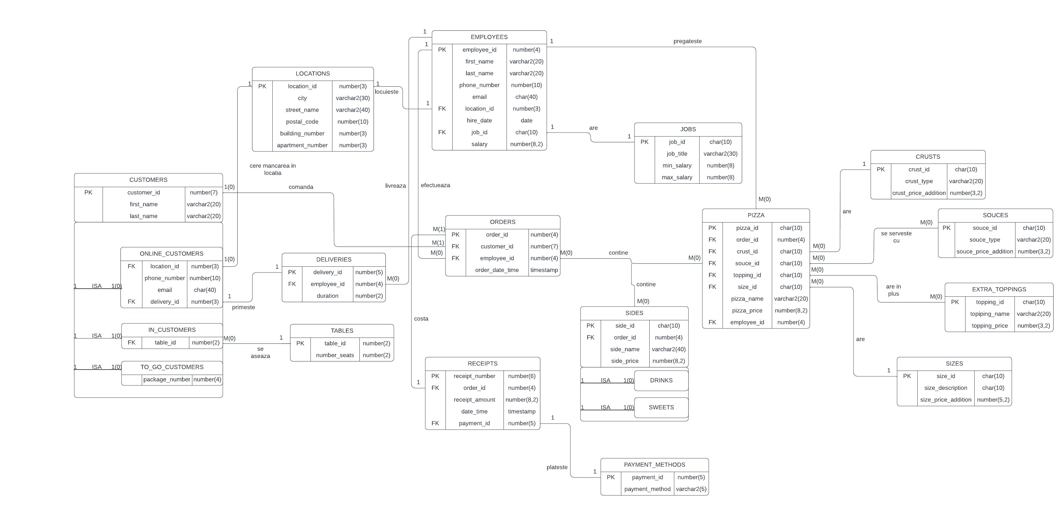

Ex3. Pornind de la diagrama entitate-relație realizați diagrama conceptuală a modelului propus, integrând toate atributele necesare.

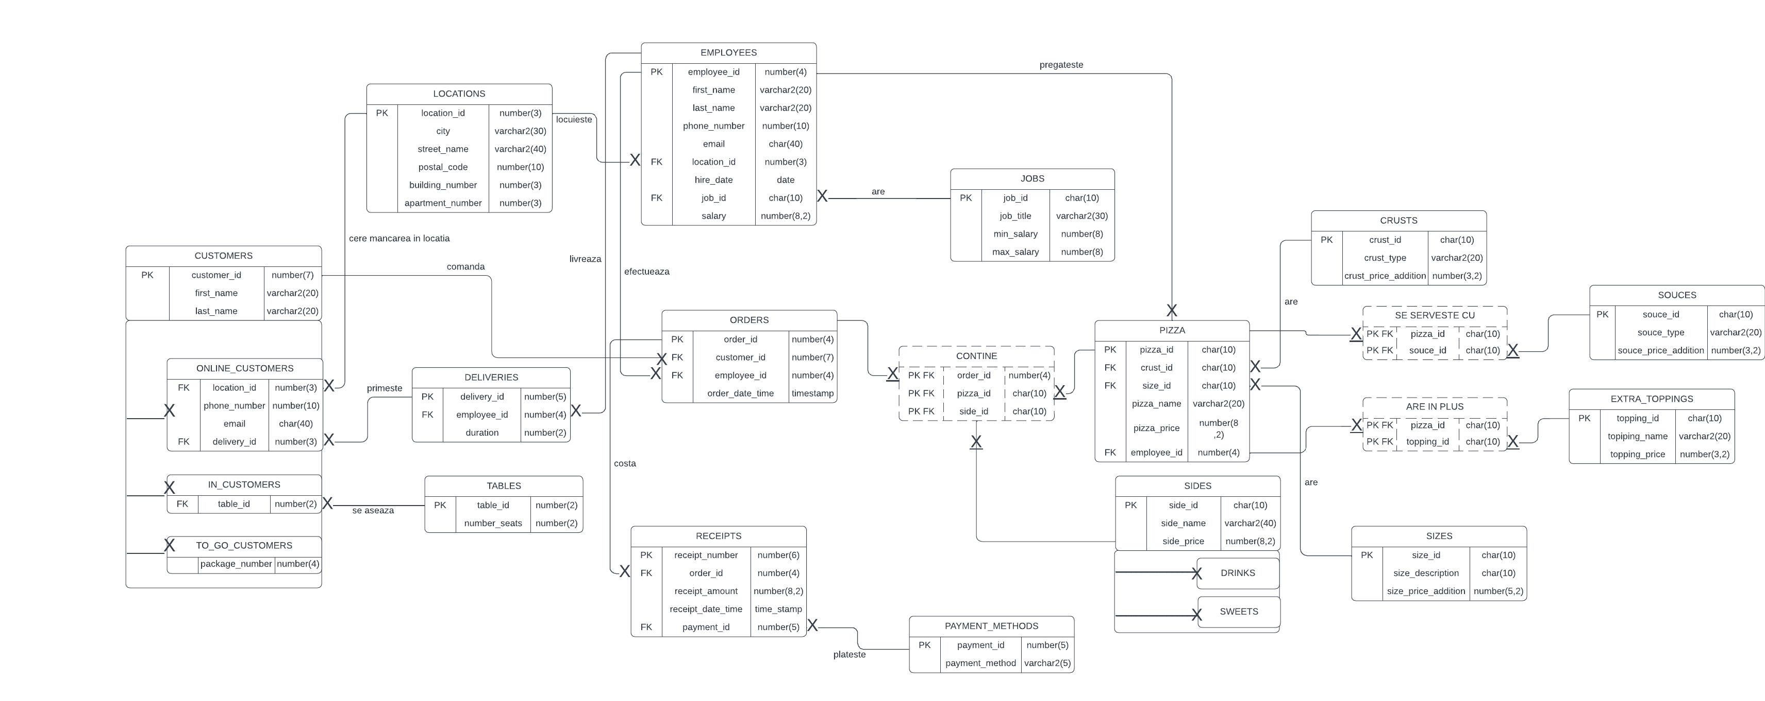

Ex4. Implementați în Oracle diagrama conceptuală realizată: definiți toate tabelele, implementând toate constrângerile de integritate necesare (chei primare, cheile externe etc).

**JOBS**

create table Jobs (job_id char(10) constraint PK_job primary key,

job_title varchar2(30) constraint job_title_const NOT NULL,

min_salary number(8) constraint min_salary_job NOT NULL,

max_salary number(8) constraint max_salary_job NOT NULL);

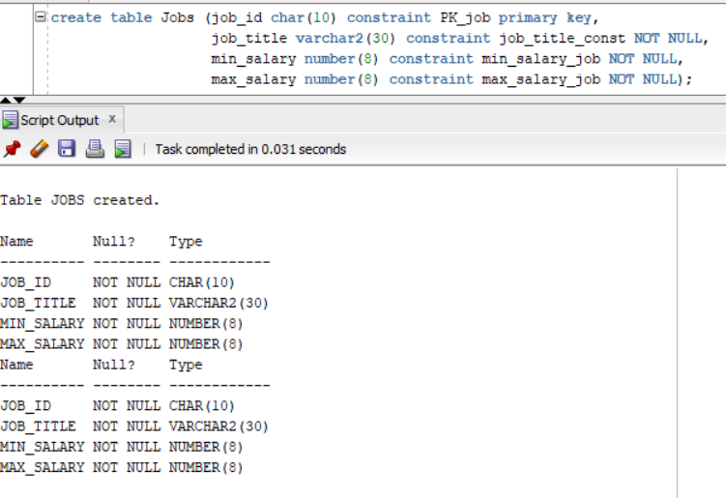

**LOCATIONS**

create table Locations (location_id number(3) constraint PK_location primary key,

city varchar2(30) constraint city_loc not null,

street_name varchar2(40) constraint street_name_loc not null,

postal_code number(10) constraint postl_code_loc not null,

building_number number(3),

apartment_number number(3));

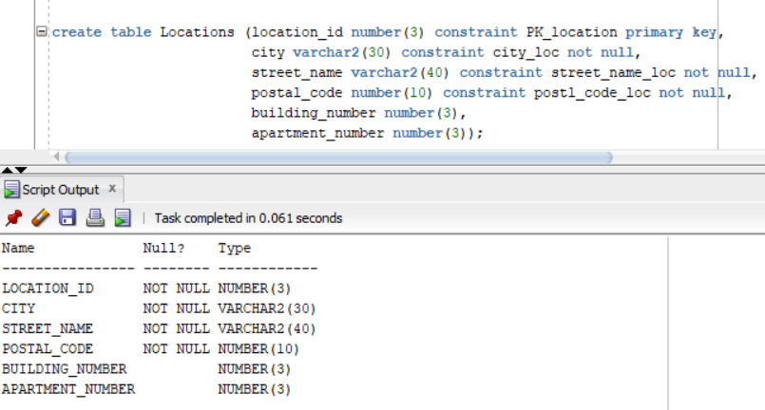

**EMPLOYEES**

create table Employees (employee_id number(4) constraint PK_employee primary key,

first_name varchar2(20) constraint last_name_emp not null,

last_name varchar2(20) constraint first_name_emp not null,

phone_number number(10) unique,

email varchar2(40) unique,

location_id number(30) constraint FK_emp_1 references Locations(location_id),

hire_date date constraint hire_date_emp not null,

job_id char(10) constraint FK_emp_2 references Jobs (job_id),

salary number(8,2) constraint salary_emp not null);

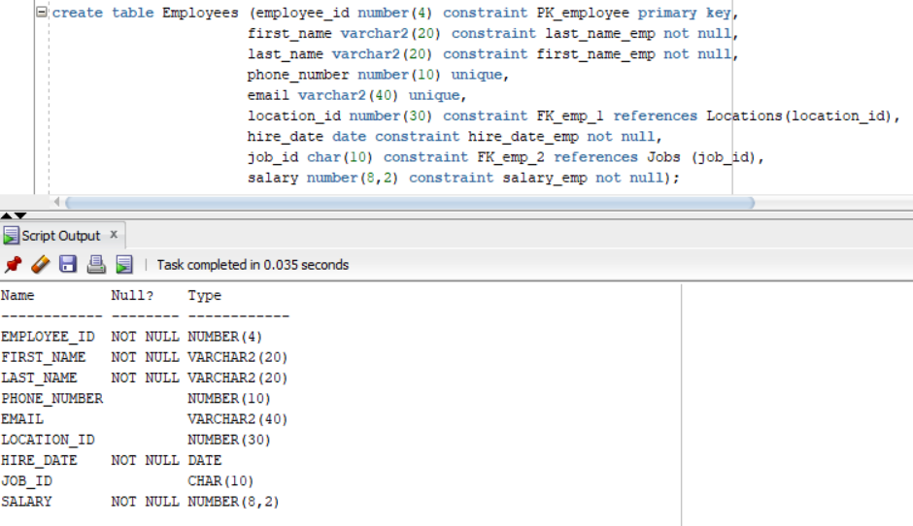

**DELIVERIES**

create table Deliveries (delivery_id number(5) constraint PK_deliv primary key,

employee_id number(4) constraint FK_deliv references Employees (employee_id),

duration number(2) constraint duration_deliv not null);

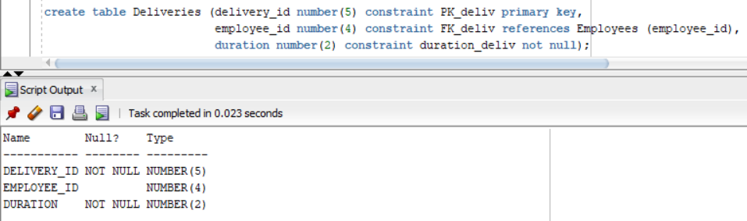

**TABLES**

create table Tables (table_id number(2) constraint PK_table primary key,

number_seats number(2) constraint number_seats_table not null);

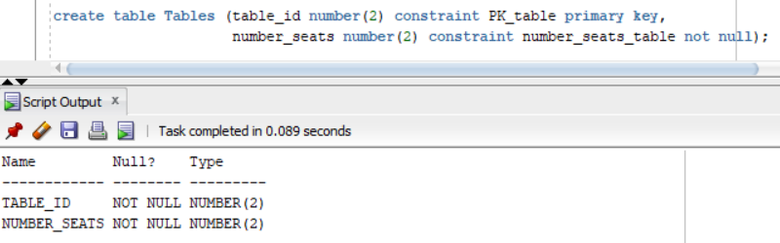

**CUSTOMERS**

create table Customers (customer_id number(7) constraint PK_customers primary key,

first_name varchar2(20) constraint first_name_cust not null,

last_name varchar2(20) constraint last_name_cust not null);

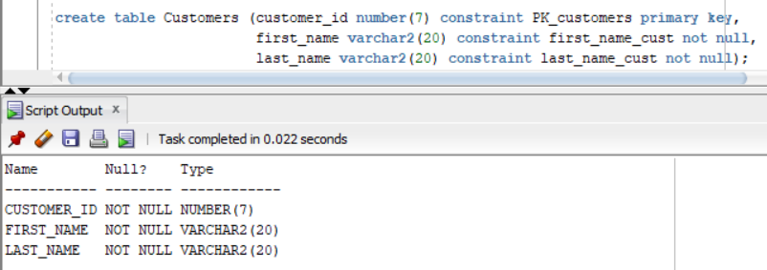

**ONLINE_CUSTOMERS**

create table Online_Customers

as select * from Customers;

delete online_customers;

alter table Online_Customers

add location_id number(3)constraint FK_ocust references Locations(location_id);

alter table Online_Customers

add phone_number number(10) unique;

alter table Online_Customers

add email char(40) unique;

alter table Online_Customers

add delivery_id number(3) constraint FK_ocust_2 references Deliveries(delivery_id);

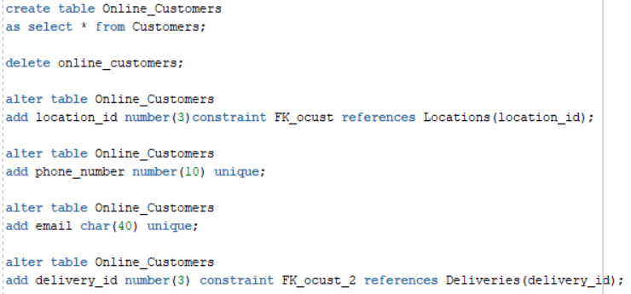

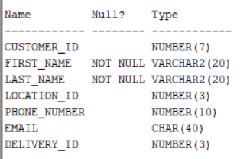

**IN_CUSTOMERS**

create table In_Customers

as select * from Customers;

delete in_customers;

alter table In_Customers

add table_id number(2) constraint FK_icust references Tables (table_id);

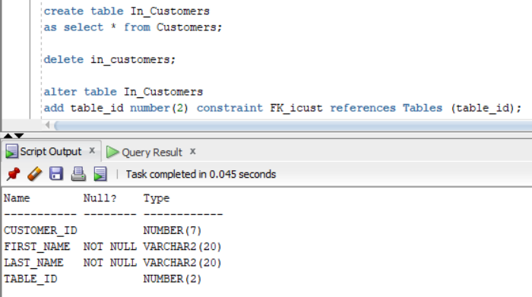

**TO_GO_CUSTOMERS**

create table To_Go_Customers

as select * from Customers;

delete to_go_customers;

alter table To_Go_Customers

add package_number number(4) constraint package_to_go not null;

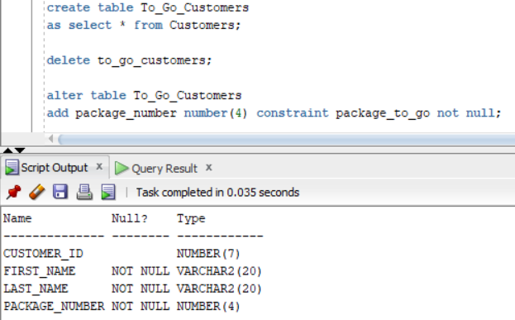

**ORDERS**

create table Orders (order_id number(4) constraint PK_order primary key,

customer_id number(7) constraint FK_ord_1 references Customers (customer_id),

employee_id number(4)constraint FK_ord_2 references Employees (employee_id),

order_date_time timestamp constraint order_date_time_ord not null);

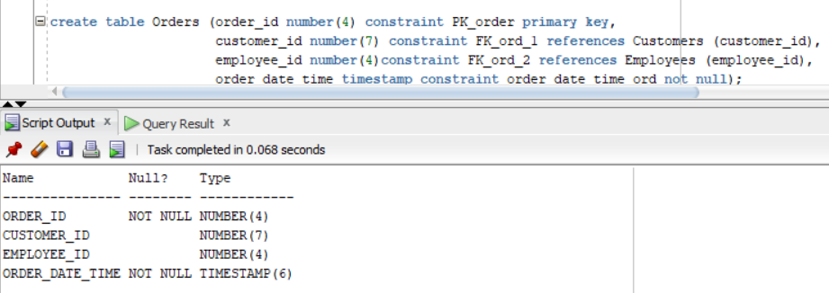

**PAYMENT_METHODS**

create table Payment_Methods (payment_id number(5) constraint PK_paym primary key,

payment_method varchar2(5) constraint pay_method not null);

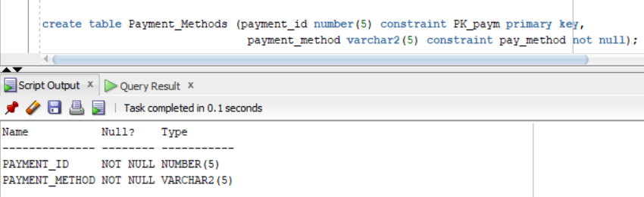

**RECEIPTS**

create sequence id_generator

start with 4111

increment by 1

maxvalue 100000

nocycle

nocache;

create table Receipts (receipt_number number(6) constraint PK_receipt primary key,

order_id number(4) constraint FK_recp_1 references Orders (order_id),

receipt_amount number(8,2) constraint amount_recp not null,

receipt_date_time timestamp constraint date_time_recp not null,

payment_id number(5)constraint FK_recp_2 references Payment_Methods (payment_id));

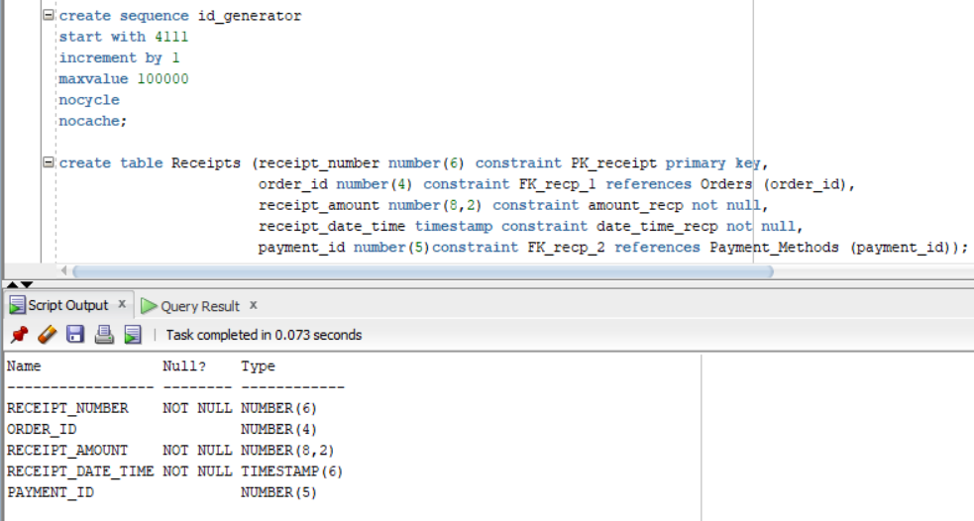

**CRUSTS**

create table Crusts (crust_id char(10) constraint PK_crust primary key,

crust_type varchar2(20) constraint crust_type_ct not null,

crust_price_addition number(3,2));

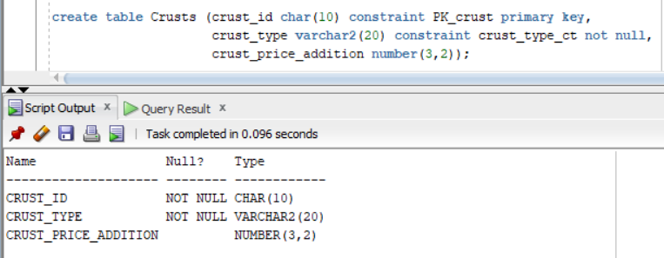

**SIZES**

create table Sizes (size_id char(10) constraint PK_size primary key,

size_description char(10) constraint size_desc not null,

size_price_addition number(5,2));

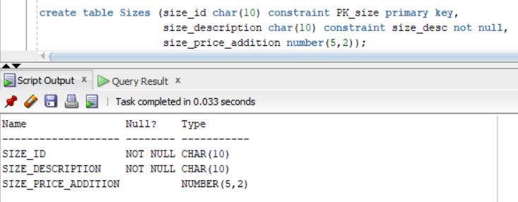

**SOUCES**

create table Souces (souce_id char(10) constraint PK_sos primary key,

souce_type varchar2(20) constraint sos_type not null,

souce_price_addition number(3,2));

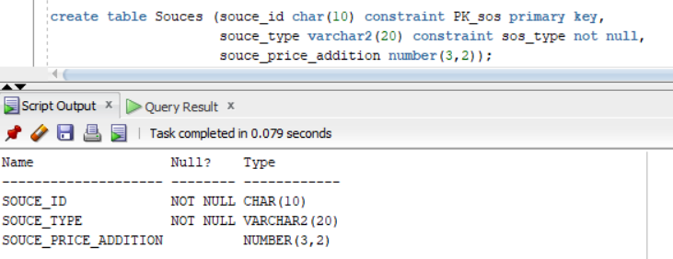

**PIZZA**

create table Pizza (pizza_id char(10) constraint PK_pizza primary key,

crust_id char(10) constraint FK_pizza_1 references Crusts (crust_id),

size_id char(10) constraint FK_pizza_2 references Sizes (size_id),

pizza_name varchar2(20) constraint pizza_name_pz not null,

pizza_price number(8,2) constraint pizza_price_pz not null,

employee_id number(4) constraint FK_pizza_3 references Employees (employee_id));

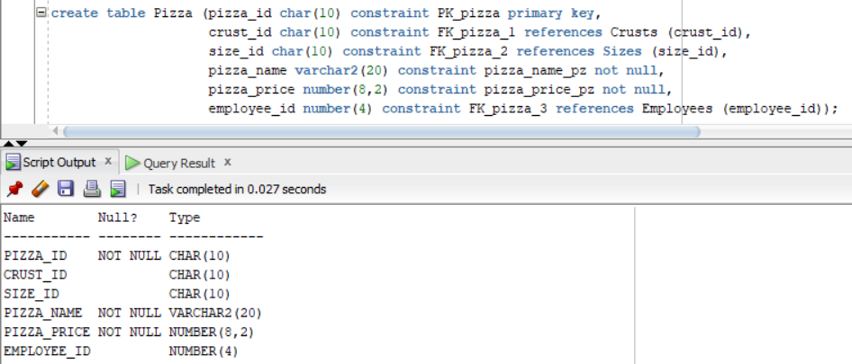

**SE_SERVESTE_CU**

create table Se_serveste_cu (pizza_id char(10) constraint PK_FK_serv_pizza references Pizza (pizza_id),

souce_id char(10) constraint PK_FK_serv_sos references Souces (souce_id));

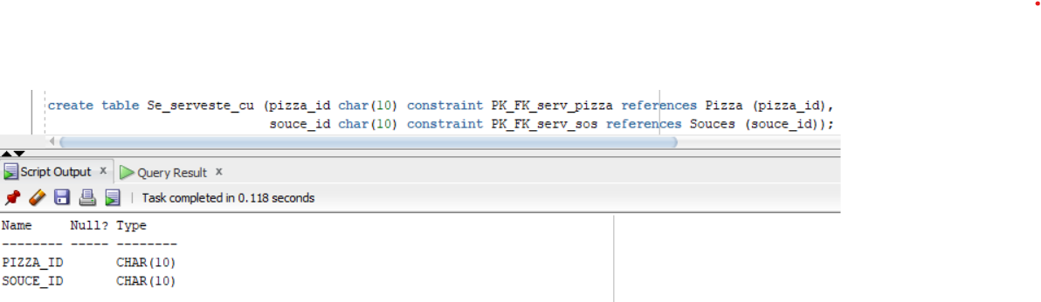

**EXTRA_TOPPINGS**

create table Extra_Toppings (topping_id char(10) constraint PK_topping primary key,

topping_name varchar2(20) constraint name_top not null,

topping_price number(3,2) constraint price_top not null);

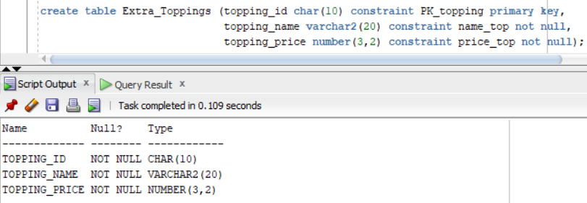

**ARE_IN_PLUS**

create table Are_in_plus (pizza_id char(10) constraint PK_FK_are_pizza references Pizza (pizza_id),

topping_id char(10) constraint PK_FK_are_topping references Extra_Toppings (topping_id));

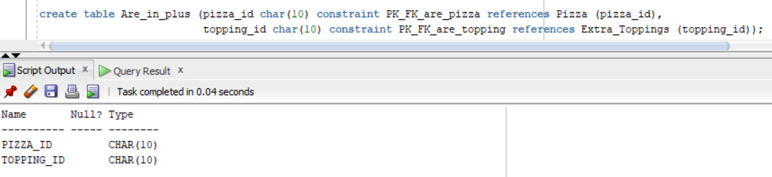

**SIDES**

create table Sides (side_id char(10) constraint PK_side primary key,

side_name varchar2(40) constraint side_name_sd not null,

side_price number(8,2) constraint side_price_sd not null);

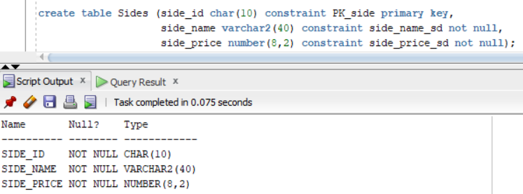

**DRINKS**

create table Drinks

as select * from Sides;

delete drinks;

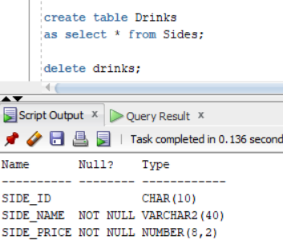

**SWEETS**

create table Sweets

as select * from Sides;

delete sweets;

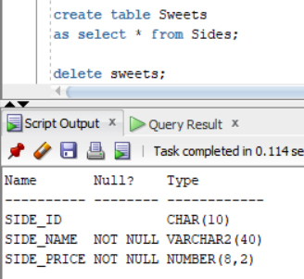

**CONTINE**

drop sequence id_generator;

create sequence id_generator

start with 301

increment by 1

maxvalue 1000

nocycle

nocache;

create table Contine (order_id number(4) constraint PK_FK_cont_ord references Orders (order_id),

pizza_id char(10) constraint PK_FK_cont_pizza references Pizza (pizza_id),

side_id char(10) constraint PK_FK_cont_side references Sides (side_id));

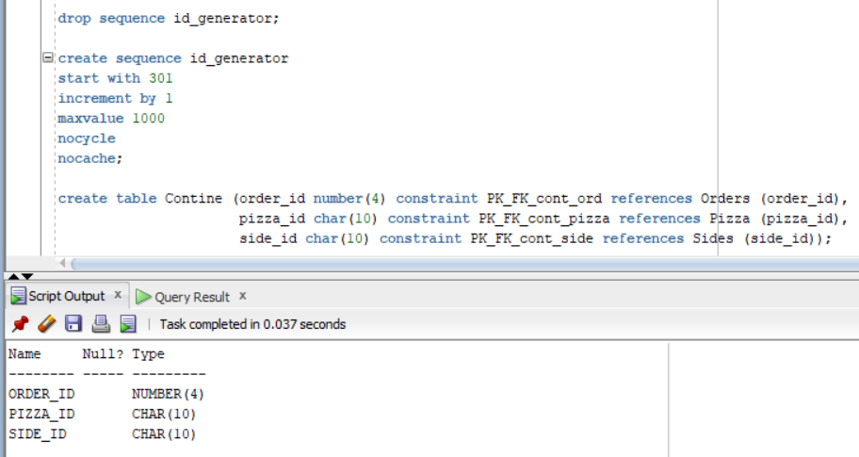

Ex5. Adăugați informații coerente în tabelele create (minim 5 înregistrări pentru fiecare entitate independentă; minim 10 înregistrări pentru tabela asociativă).

**JOBS**

insert into jobs values('MG', 'Manager', 70000, 85000);

insert into jobs values('CT', 'Contabil', 20000, 30000);

insert into jobs values('CH', 'Bucatar', 65000, 70000);

insert into jobs values('ASC', 'Asistent de bucatar', 40000, 50000);

insert into jobs values('W', 'Chelner', 15000, 25000);

insert into jobs values('CAS', 'Casier', 10000, 20000);

insert into jobs values('SER', 'Om de serviciu', 10000, 13000);

insert into jobs values('DEL', 'Curier', 13000, 17000);

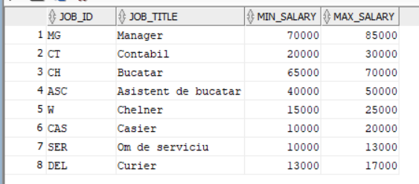

**LOCATIONS**

insert into locations values(1, 'Ploiesti', 'Gornistilor', 10455, 130, 6);

insert into locations values(2, 'Ploiesti', 'Zamora', 10305, 43, 2);

insert into locations values(3, 'Ploiesti', 'Beius', 10080, 13,null);

insert into locations values(4, 'Ploiesti', 'Grindului', 10045, 56, 9);

insert into locations values(5, 'Ploiesti', 'Porumbitei', 10235, 160, 4);

insert into locations values(6, 'Ploiesti', 'Vi?inilor', 10897, 29, 14);

insert into locations values(7, 'Ploiesti', 'Regimentului', 10009, 49, null);

insert into locations values(8, 'Ploiesti', '8 Martie', 10570, 68, null);

insert into locations values(9, 'Ploiesti', 'Albinei', 10056, 98, 10);

insert into locations values(10, 'Ploiesti', 'Cameliei', 10017, 142, null);

insert into locations values(11, 'Ploiesti', 'Dumbravei', 10115, 124, 5);

insert into locations values(12, 'Ploiesti', 'Fluturilor', 10408, 119, 107);

insert into locations values(13, 'Ploiesti', 'Gheorghe Doja', 10023, 52, 1);

insert into locations values(14, 'Ploiesti', 'Furnica', 10222, 407, 3);

insert into locations values(15, 'Ploiesti', 'Ion Heliade', 10670, 35, null);

insert into locations values(16, 'Ploiesti', 'Malu Rosu', 10440, 170, 7);

insert into locations values(17, 'Ploiesti', 'Miorita', 10013, 14, null);

insert into locations values(18, 'Ploiesti', 'Negoiu', 10079, 6, null);

insert into locations values(19, 'Ploiesti', 'Jupiter', 10005, 233, 8);

insert into locations values(20, 'Ploiesti', 'Cascade', 10555, 66, 12);

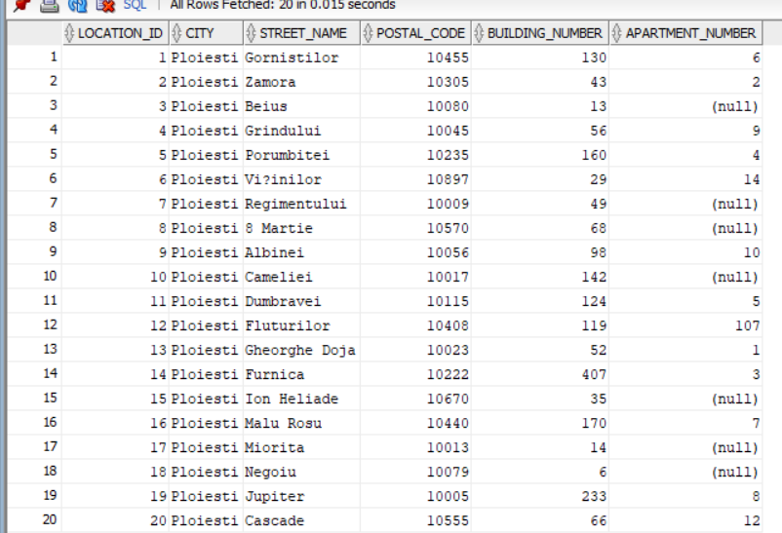

**EMPLOYEES**

insert into employees values(101, 'Evelyn', 'Harper', 0785908519,'evelynH@gmail.com', 8, '06-NOV-00', 'MG', 75000);

insert into employees values(102, 'Benjamin', 'Garcia', 0770874084,'benjG@gmail.com', 12, '16-SEP-17', 'W', 25000);

insert into employees values(103, 'Ava', 'Brown', 0709472439,'avaB@gmail.com', 4, '04-MAR_20', 'W', 15000);

insert into employees values(104, 'Isabella', 'Smith', 0774080650,'isabellaS@gmail.com', 14, '25-NOV-96', 'CH', 70000);

insert into employees values(105, 'Amelia', 'Hill', 0727314772,'ameliaH@gmail.com', 18, '27-DEC-10', 'DEL', 16000);

insert into employees values(106, 'Sophia', 'Wlliams', 0760803376,'sophiaW@gmail.com', 9, '24-JUL-15', 'W', 18000);

insert into employees values(107, 'Charlotte', 'Moore', 0767231470,'chrM@gmail.com', 15, '28-OCT_04', 'SER', 11000);

insert into employees values(108, 'Emma', 'Donovan', 0746107617,'emmaD@gmail.com', 17, '13-NOV-15', 'ASC', 45000);

insert into employees values(109, 'Oliver', 'Carter', 0781361168,'oliverC@gmail.com', 2, '11_MAR-11', 'CT', 30000);

insert into employees values(110, 'Thodore', 'Miller', 0702116148,'theoM@gmail.com', 13, '06-FEB-07', 'CAS', 13000);

insert into employees values(111, 'Lucas', 'Davis', 0720186396,'lucasD@gmail.com', 1, '03-FEB-99', 'ASC', 50000);

insert into employees values(112, 'Robert', 'Lewis', 0738787442,'robertL@gmail.com', 10, '03-APR-99', 'DEL', 15000);

insert into employees values(113, 'Henry', 'Andrews', 0719125076,'henryA@gmail.com', 11, '10-JUN-04', 'CH', 65000);

insert into employees values(114, 'Mia', 'Thomas', 0775596028,'miaT@gmail.com', 6, '09-MAY-97', 'CAS', 19000);

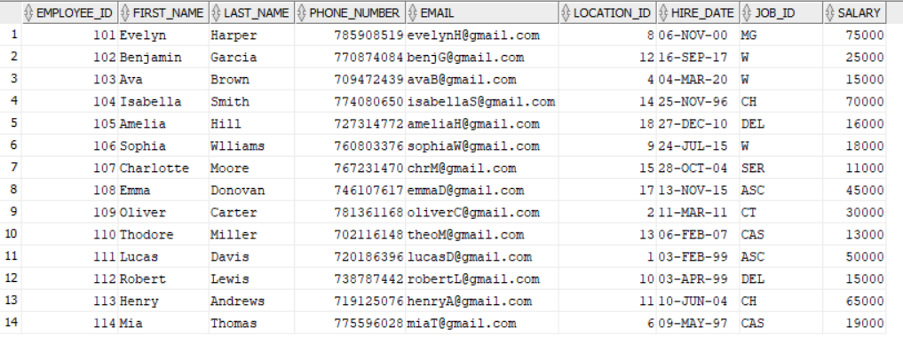

**DELIVERIES**

insert into deliveries values(21, 112, 31);

insert into deliveries values(22, 105, 43);

insert into deliveries values(23, 105, 26);

insert into deliveries values(24, 112, 17);

insert into deliveries values(25, 105, 35);

insert into deliveries values(26, 112, 14);

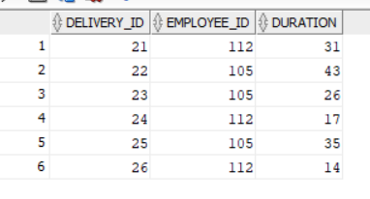

**TABLES**

insert into tables values(1, 4);

insert into tables values(2, 2);

insert into tables values(3, 6);

insert into tables values(4, 4);

insert into tables values(5, 2);

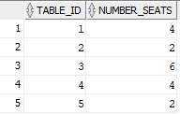

**CUSTOMERS**

insert into Customers values(1121, 'Ronald', 'Macias');

insert into Customers values(1122, 'Caoimhe', 'Rosario');

insert into Customers values(1123, 'Harry', 'Dunne');

insert into Customers values(1124, 'Chanice', 'Rollins');

insert into Customers values(1125, 'Jayden-Lee', 'Davidson');

insert into Customers values(1126, 'Kinga', 'Betts');

insert into Customers values(1127, 'Catriona', 'Mclean');

insert into Customers values(1128, 'Bradleig', 'Parrish');

insert into Customers values(1129, 'Callum', 'Clarkson');

insert into Customers values(1130, 'Jaxson', 'Leach');

insert into Customers values(1131, 'Jordanne', 'Corona');

insert into Customers values(1132, 'Fintan', 'Adkins');

insert into Customers values(1133, 'Rea', 'Savage');

insert into Customers values(1134, 'Samanta', 'Callahan');

insert into Customers values(1135, 'Spencer', 'Wagner');

insert into Customers values(1136, 'Karen', 'Willow');

insert into Customers values(1137, 'Meghan', 'Dunne');

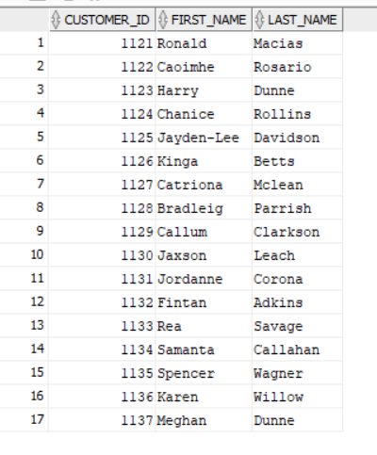

**ONLINE_CUSTOMERS**

insert into Online_Customers values(1127, 'Catriona', 'Mclean', 16, 0795051829, 'catrionaM@gmail.com', 24);

insert into Online_Customers values(1135, 'Spencer', 'Wagner', 5, 0708182478, 'spencerW@gmaul.com', 22);

insert into Online_Customers values(1123, 'Harry', 'Dunne', 3, 0707166155, 'harryD@gmail.com', 21);

insert into Online_Customers values(1132, 'Fintan', 'Adkins', 19, 0727985820, 'fintanA@gmail.com', 25);

insert into Online_Customers values(1125, 'Jayden-Lee', 'Davidson', 7, 0782989362, 'jaydenD@gmail.com', 23);

insert into Online_Customers values(1137, 'Meghan', 'Dunne', 20, 0729006553, 'meghanDD@gmail.com', 26)

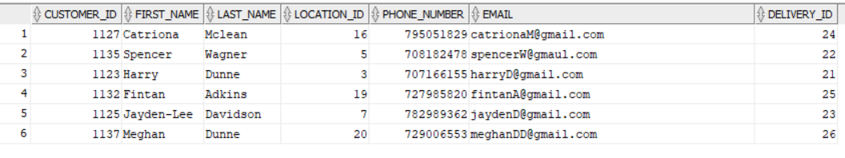

**IN_CUSTOMERS**

insert into In_Customers values(1133, 'Rea', 'Savage', 3);

insert into In_Customers values(1126, 'Kinga', 'Betts', 1);

insert into In_Customers values(1121, 'Ronald', 'Macias', 2);

insert into In_Customers values(1134, 'Samanta', 'Callahan', 2);

insert into In_Customers values(1128, 'Bradleig', 'Parrish', 4);

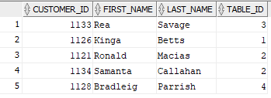

**TO_GO_CUSTOMERS**

insert into To_Go_Customers values(1122, 'Caoimhe', 'Rosario', 11);

insert into To_Go_Customers values(1124, 'Chanice', 'Rollins', 12);

insert into To_Go_Customers values(1129, 'Callum', 'Clarkson', 13);

insert into To_Go_Customers values(1130, 'Jaxson', 'Leach', 14);

insert into To_Go_Customers values(1131, 'Jordanne', 'Corona', 15);

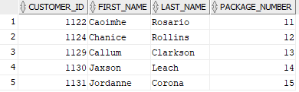

**ORDERS**

insert into orders values(301, 1121, 102, '3-FEB-20 10:30:15');

insert into orders values(302, 1122, 103, '18_FEB-20 10:45:07');

insert into orders values(303, 1123, 106, '12_APR_20 11:30:29');

insert into orders values(304, 1124, 102, '2-MAY-20 12:30:36');

insert into orders values(305, 1125, 103, '8-MAY-20 12:45:18');

insert into orders values(306, 1126, 106, '25-JUN-20 13:15:20');

insert into orders values(307, 1127, 102, '23-AUG-20 14:30:42');

insert into orders values(308, 1128, 103, '2-SEP-20 15:32:09');

insert into orders values(309, 1129, 106, '16-SEP-20 16:45:57');

insert into orders values(310, 1130, 102, '1-FEB-21 17:00:18');

insert into orders values(311, 1131, 103, '11-FEB-21 17:45:02')

insert into orders values(312, 1132, 106, '13-APR-21 18:00:11');

insert into orders values(313, 1133, 102, '15-MAY-21 19:15:24');

insert into orders values(314, 1134, 103, '22-JUL-21 19:45:13');

insert into orders values(315, 1135, 106, '17-NOV-21 20:00:55');

insert into orders values(316, 1131, 102, '14-DEC-21 9:23:15');

insert into orders values(317, 1137, 103, '28-SEP-21 15:10:00');

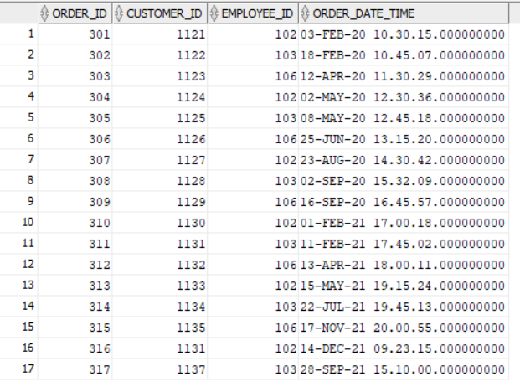

**PAYMENT_METHODS**

insert into payment_methods values(41, 'cash');

insert into payment_methods values(42, 'card');

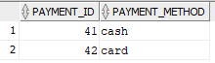

**RECEIPTS**

insert into receipts values(id_generator.nextval, 301, 28.55, '3-FEB-20 12:05:23', 41);

insert into receipts values(id_generator.nextval, 302, 93.4, '18_FEB-20 11:10:42', 42);

insert into receipts values(id_generator.nextval, 303, 52.05, '12_APR_20 12:08:12', 42);

insert into receipts values(id_generator.nextval, 304, 47.45, '2-MAY-20 12:55:04', 41);

insert into receipts values(id_generator.nextval, 305, 42.95, '8-MAY-20 13:32:36', 41);

insert into receipts values(id_generator.nextval, 306, 58.45, '25-JUN-20 15:37:15', 42);

insert into receipts values(id_generator.nextval, 307, 46, '23-AUG-20 15:14:08', 42);

insert into receipts values(id_generator.nextval, 308, 12.95, '2-SEP-20 16:51:23', 41);

insert into receipts values(id_generator.nextval, 309, 24.75, '16-SEP-20 17:12:38', 41);

insert into receipts values(id_generator.nextval, 310, 6.5, '1-FEB-21 17:06:32', 41);

insert into receipts values(id_generator.nextval, 311, 26.65, '11-FEB-21 16:01:14 ', 42);

insert into receipts values(id_generator.nextval, 312, 70.2, '13-APR-21 18:42:56', 42);

insert into receipts values(id_generator.nextval, 313, 58.55, '15-MAY-21 21:14:03', 42);

insert into receipts values(id_generator.nextval, 314, 62.9, '22-JUL-21 21:32:47', 42);

insert into receipts values(id_generator.nextval, 315, 40.05, '17-NOV-21 20:35:26', 41);

insert into receipts values(id_generator.nextval, 316, 53.95, '14-DEC-21 11:21:04 ', 41);

insert into receipts values(id_generator.nextval, 317, 12.95, '28-SEP-21 16:23:12', 42);

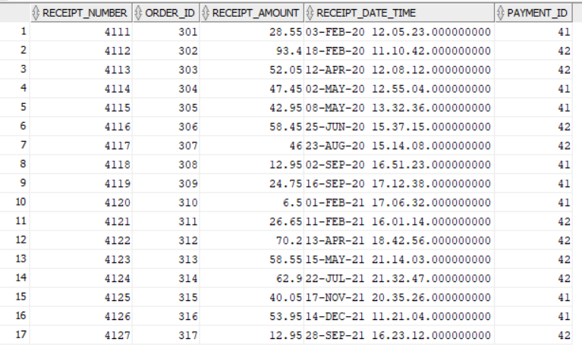

**CRUSTS**

insert into crusts values('NOR', 'Blat normal', null);

insert into crusts values('ITA', 'Blat italian', null);

insert into crusts values('PHI', 'Blat Philadelphia', 6.5);

insert into crusts values('CRC', 'Blat crocant', 6.5);

insert into crusts values('PUF', 'Blat pufos', 6.5);

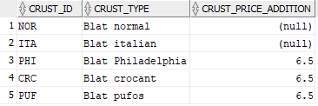

**SIZES**

insert into sizes values('MICA', '6 felii', null);

insert into sizes values('MEDIE', '8 felii', 13);

insert into sizes values('MARE', '12 felii', 25.5);

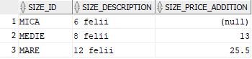

**SOUCES**

insert into souces values('SW', 'Sos dulce', null);

insert into souces values('HOT', 'Sos picant', 4);

insert into souces values('GAR', 'Sos de usturoi', 4);

insert into souces values('SCH', 'Sos sweet chilli', 4);

insert into souces values('BBQ', 'Sos BBQ', 4);

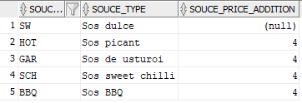

**PIZZA**

insert into pizza values('QFNMi', 'NOR', 'MICA', 'Quattro Formaggi', 28.55, 104);

insert into pizza values('PIMe', 'ITA', 'MEDIE', 'Pepperoni', 42.95, 108);

insert into pizza values('CaPMe', 'PUF', 'MEDIE', 'Carnivora', 52.05, 111);

insert into pizza values('DNMa', 'NOR', 'MARE', 'Diavola', 47.45, 113);

insert into pizza values('CPMe', 'PHI', 'MEDIE', 'Capriciosa', 45.45, 104);

insert into pizza values('PFCMa', 'CRC', 'MARE', 'Prosciutto Funghi', 51.95, 108);

insert into pizza values('QSPMi', 'PUF', 'MICA', 'Quattro Stagioni', 35.05, 111);

insert into pizza values('VNMe', 'NOR', 'MEDIE', 'Vegetariana', 36.95, 113);

insert into pizza values('PFIMa', 'ITA', 'MARE', 'Prosciutto Funghi', 55.95, 104);

insert into pizza values('CaPhMi', 'PHI', 'MICA', 'Carnivora', 37.05, 113);

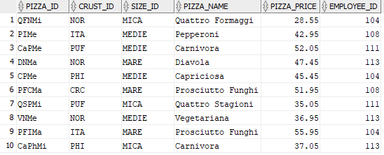

**SE_SERVESTE_CU**

insert into se_serveste_cu values('QSPMi','GAR');

insert into se_serveste_cu values('QFNMi','SW');

insert into se_serveste_cu values('CPMe','HOT');

insert into se_serveste_cu values('CaPMe','GAR');

insert into se_serveste_cu values('PFCMa','SCH');

insert into se_serveste_cu values('QSPMi','SW');

insert into se_serveste_cu values('PFCMa','HOT');

insert into se_serveste_cu values('CPMe','BBQ');

insert into se_serveste_cu values('CaPMe','SW');

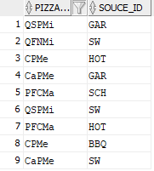

**EXTRA_TOPPINGS**

insert into extra_toppings values('CHE', 'Branza', 2);

insert into extra_toppings values('OL', 'Masilne', 2);

insert into extra_toppings values('MSH', 'Ciuperci', 2);

insert into extra_toppings values('PER', 'Ardei', 2);

insert into extra_toppings values('CN', 'Porumb', 2);

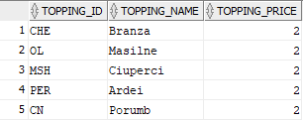

**ARE_IN_PLUS**

insert into are_in_plus values('PIMe','CHE');

insert into are_in_plus values('DNMa','OL');

insert into are_in_plus values('DNMa','MSH');

insert into are_in_plus values('CPMe','PER');

insert into are_in_plus values('PFCMa','CN');

insert into are_in_plus values('PFCMa','CHE');

insert into are_in_plus values('CPMe','MSH');

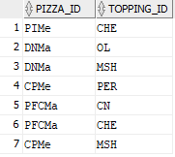

**SIDES**

insert into sides values('AP', 'Apa Plata', 5);

insert into sides values('CP', 'Choco Pizza', 26.65);

insert into sides values('FN', 'Fanta', 6.5);

insert into sides values('SC', 'Soufle de ciocolata', 10.95);

insert into sides values('CC', 'Coca Cola', 6.5);

insert into sides values('CLC', 'Clatite cu ciocolata', 14.55);

insert into sides values('FP', 'Frappe', 12.95);

insert into sides values('APP', 'Placinta cu mere', 16.25);

insert into sides values('ES', 'Espresso', 8.5);

insert into sides values('ICE', 'Inghetata asortata', 10.95);

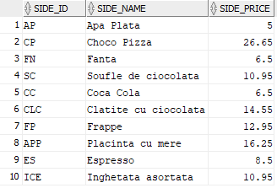

**DRINKS**

insert into drinks values('AP', 'Apa Plata', 5);

insert into drinks values('FN', 'Fanta', 6.5);

insert into drinks values('CC', 'Coca Cola', 6.5);

insert into drinks values('FP', 'Frappe', 12.95);

insert into drinks values('ES', 'Espresso', 8.5);

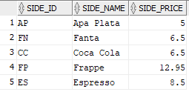

**SWEETS**

insert into sweets values('CP', 'Choco Pizza', 26.65);

insert into sweets values('SC', 'Soufle de ciocolata', 10.95);

insert into sweets values('CLC', 'Clatite cu ciocolata', 14.55);

insert into sweets values('APP', 'Placinta cu mere', 16.25);

insert into sweets values('ICE', 'Inghetata asortata', 10.95);

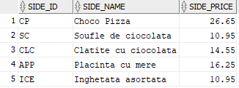

**CONTINE**

insert into contine values(id_generator.nextval , 'QFNMi', null);

insert into contine values(id_generator.nextval , 'PIMe', null);

insert into contine values(id_generator.nextval , 'CaPMe', null);

insert into contine values(id_generator.nextval , 'DNMa', null);

insert into contine values(id_generator.nextval , 'PIMe', null);

insert into contine values(id_generator.nextval , 'PFCMa','CC');

insert into contine values(id_generator.nextval , 'QSPMi','SC');

insert into contine values(id_generator.nextval , null ,'FP');

insert into contine values(id_generator.nextval , null ,'ES');

insert into contine values(id_generator.nextval , null ,'FN');

insert into contine values(id_generator.nextval , null ,'CP');

insert into contine values(id_generator.nextval , 'DNMa' ,'APP');

insert into contine values(id_generator.nextval , 'CaPMe' ,'FN');

insert into contine values(id_generator.nextval , 'PFCMa','ICE');

insert into contine values(id_generator.nextval , 'QSPMi' ,'AP');

insert into contine values(id_generator.nextval , 'DNMa' ,'CC');

insert into contine values(id_generator.nextval , null ,'FP');

insert into contine values(302 , 'CPMe', 'AP');

insert into contine values(309 , null ,'APP');

insert into contine values(312 , null ,'CC');

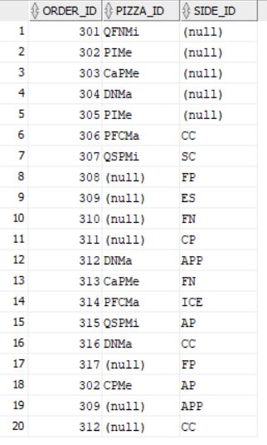

Ex6. Formulați în limbaj natural o problemă pe care să o rezolvați folosind un subprogram stocat independent care să utilizeze două tipuri diferite de colecții studiate. Apelați subprogramul.

Pentru fiecare comanda sa se afiseze numele si tipul de blat ai fiecarei pizze sau sa se afiseze "Nu contine pizza" cand comanda nu contine pizza.

SET SERVEROUTPUT ON;

CREATE OR REPLACE PROCEDURE ex6

IS

--in t1 retin toate comenzile

TYPE t_imbricat IS TABLE OF orders.order_id%type;

t1 t_imbricat;

--in t2 retin toate pizzele din fiecare comanda din t1

TYPE vector IS VARRAY(10) OF pizza.pizza_id%type;

t2 vector:= vector();

i NUMBER(2):=0;

j NUMBER(2):=0;

nr NUMBER(2):=0;

blat crusts.crust_type%type;

nume pizza.pizza_name%type;

BEGIN

SELECT order_id

BULK COLLECT INTO t1

FROM orders;

FOR i in t1.FIRST..t1.LAST LOOP

DBMS_OUTPUT.PUT_LINE('Comanda '|| t1(i)||': ');

SELECT pizza_id

BULK COLLECT INTO t2

FROM contine

WHERE order_id = t1(i);

nr:=0;

FOR j in t2.FIRST..t2.LAST LOOP

IF t2(j) IS NOT NULL THEN

SELECT p.pizza_name, c.crust_type

INTO nume, blat

FROM crusts c, pizza p

WHERE c.crust_id = p.crust_id

AND p.pizza_id = t2(j);

DBMS_OUTPUT.PUT_LINE('Pizza '|| nume||' cu '|| blat);

nr:= nr+1;

END IF;

END LOOP;

IF nr = 0 THEN

DBMS_OUTPUT.PUT_LINE('Nu contine pizza');

END IF;

t2.delete;

DBMS_OUTPUT.PUT_LINE(' ');

END LOOP;

END ex6;

/

BEGIN

ex6;

END;

/

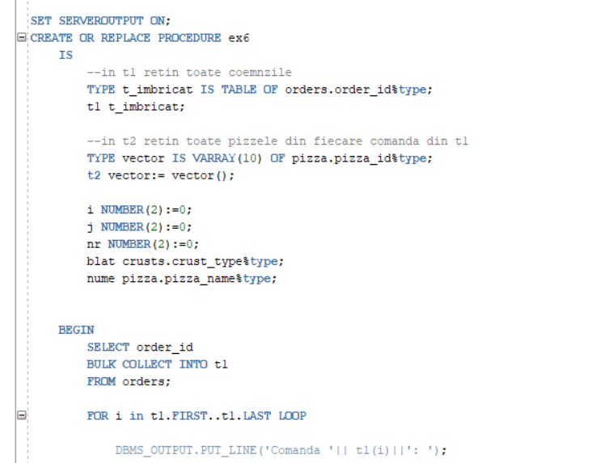

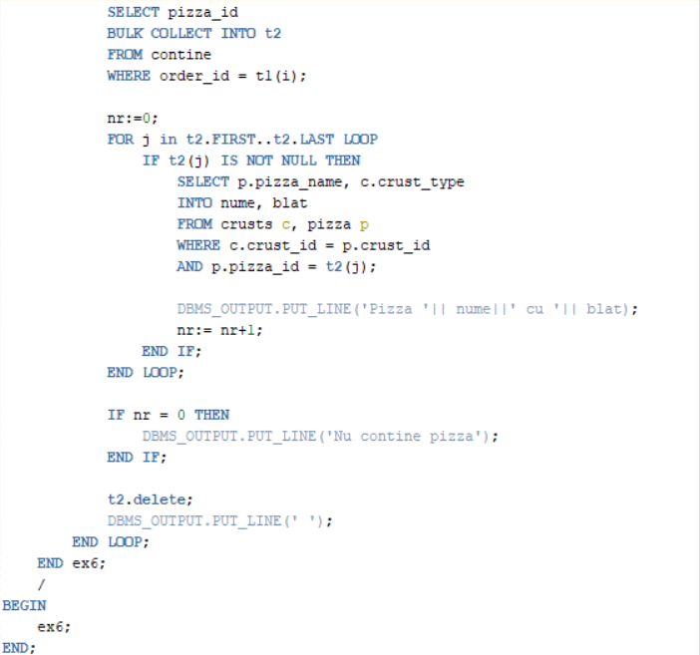

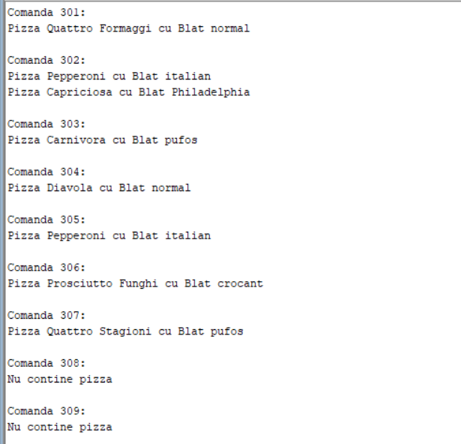

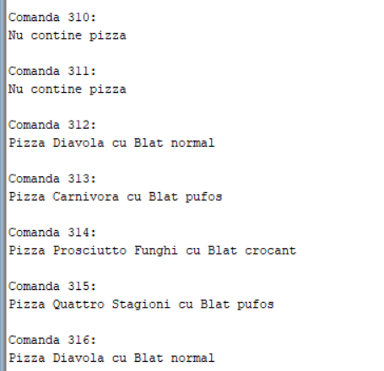

Ex7. Formulați în limbaj natural o problemă pe care să o rezolvați folosind un subprogram stocat independent care să utilizeze 2 tipuri diferite de cursoare studiate, unul dintre acestea fiind cursor parametrizat. Apelați subprogramul.

Sa se afiseze numele, prenumele si numele jobului angajatilor care au salariul minim mai mare decat o suma data ca parametru si care au fost angajati dupa anul 2000.

CREATE OR REPLACE PROCEDURE ex7 (salariu jobs.min_salary%type)

IS

--in c1 retin id-ul si numele joburilor cu salariul minim mai mare decat salariul dat ca parametru

CURSOR c1 IS

SELECT job_id, job_title

FROM jobs

WHERE min_salary > salariu;

--in c2 retin numele, prenumele si data angajarii angajatilor pentru fiecare job din c1

CURSOR c2 (job jobs.job_id%type) IS

SELECT last_name, first_name, hire_date

FROM employees

WHERE job_id = job;

v_nume employees.last_name%type;

v_prenume employees.first_name%type;

v_data employees.hire_date%type;

BEGIN

FOR i in c1 LOOP

open c2(i.job_id);

LOOP

FETCH c2 INTO v_nume, v_prenume, v_data;

EXIT WHEN c2%NOTFOUND;

IF to_char(v_data, 'YYYY')>=2000 THEN

DBMS_OUTPUT.PUT_LINE(i.job_title || ' ' || v_nume || ' ' || v_prenume);

END IF;

END LOOP;

CLOSE c2;

END LOOP;

END ex7;

/

BEGIN

ex7(15000);

END;

/

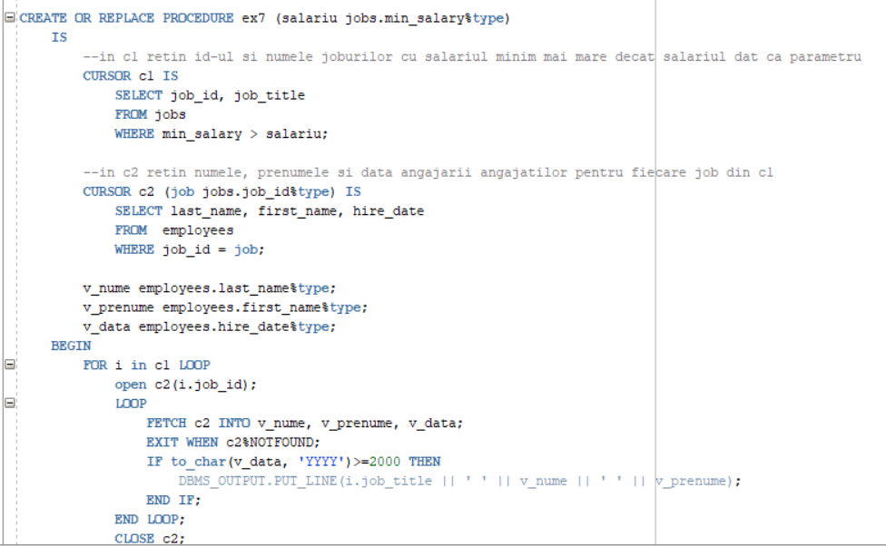

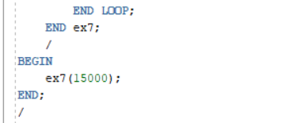

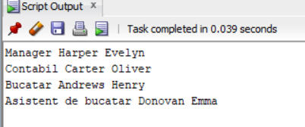

Ex8. Formulați în limbaj natural o problemă pe care să o rezolvați folosind un subprogram stocat independent de tip funcție care să utilizeze într-o singură comandă SQL 3 dintre tabelele definite. Definiți minim 2 excepții. Apelați subprogramul astfel încât să evidențiați toate cazurile tratate.

Fiind dat ca parametru numele unui client, sa se afiseze suma totala a comenzilor plasate de acesta. Sa se trateze cazurile in care exista mai multi clienti cu acelasi nume si daca nu exista clienti cu numele dat.

CREATE OR REPLACE FUNCTION ex8(v_nume customers.last_name%type)

RETURN NUMBER IS rezultat NUMBER(10,2);

contor NUMBER;

BEGIN

--tratare exceptii

SELECT COUNT(*)

INTO contor

FROM customers

WHERE last_name = v_nume;

IF contor = 0 THEN

RAISE_APPLICATION_ERROR(-20000, 'Nu exista clienti cu numele dat');

ELSIF contor>1 THEN

RAISE_APPLICATION_ERROR(-20001, 'Exista mai multi clienti cu numele dat');

END IF;

SELECT SUM(r.receipt_amount)

INTO rezultat

FROM customers c

JOIN orders o ON c.customer_id = o.customer_id

JOIN receipts r ON o.order_id = r.order_id

AND c.last_name = v_nume;

RETURN rezultat;

END ex8;

/

BEGIN

DBMS_OUTPUT.PUT_LINE(ex8('Corona'));

--DBMS_OUTPUT.PUT_LINE(ex8('Coron'));

--DBMS_OUTPUT.PUT_LINE(ex8('Dunne'));

END;

/

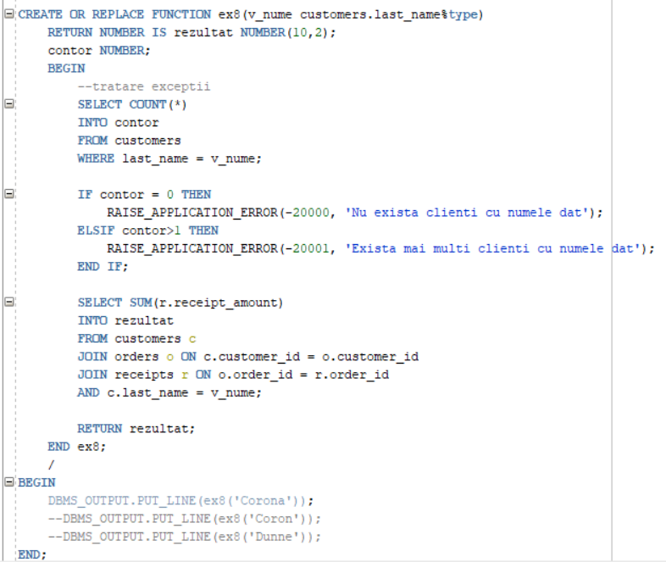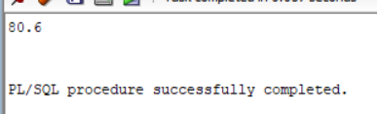

Prima exceptie:

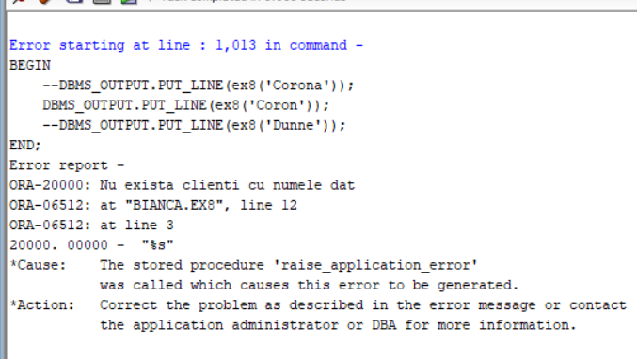

A doua exceptie:

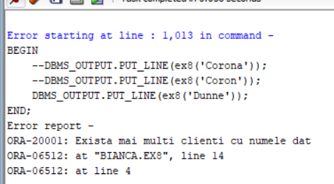

Ex9. Formulați în limbaj natural o problemă pe care să o rezolvați folosind un subprogram stocat independent de tip procedură care să utilizeze într-o singură comandă SQL 5 dintre tabelele definite. Tratați toate excepțiile care pot apărea, incluzând excepțiile NO_DATA_FOUND și TOO_MANY_ROWS. Apelați subprogramul astfel încât să evidențiați toate cazurile tratate.

Fiind dat ca parametru numele unui client, in cazul in care a plasat comanda online, sa se afiseze numele clientului, orasul, strada si metoda de plata. Sa se trateze cazurile in care nu exista un client cu acest nume, clientul respectiv nu a plasat o comanda online sau exista mai multi clienti cu acest nume care au plasat o comanda online.

CREATE OR REPLACE PROCEDURE ex9(nume IN OUT online_customers.last_name%type,

oras OUT locations.city%type,

strada OUT locations.street_name%type,

plata OUT payment_methods.payment_method%type)

IS

contor NUMBER;

exceptie EXCEPTION;

BEGIN

SELECT COUNT(*)

INTO contor

FROM customers

WHERE last_name = nume;

IF contor = 0 THEN

RAISE exceptie;

END IF;

SELECT l.city, l.street_name, p.payment_method

INTO oras, strada, plata

FROM online_customers c, locations l, orders o, receipts r, payment_methods p

WHERE c.location_id = l.location_id

AND c.customer_id = o.customer_id

AND r.order_id = o.order_id

AND r.payment_id = p.payment_id

AND c.last_name = nume;

EXCEPTION

WHEN NO_DATA_FOUND THEN

RAISE_APPLICATION_ERROR(-20000, 'Nu exista clienti care au plasat comanda online cu numele dat');

WHEN TOO_MANY_ROWS THEN

RAISE_APPLICATION_ERROR(-20001, 'Exista mai multi clienti care au plasat comanda online cu numele dat');

WHEN exceptie THEN

RAISE_APPLICATION_ERROR(-20002, 'Nu exista clienti cu numele dat');

END ex9;

/

DECLARE

v_nume online_customers.last_name%type;

v_oras locations.city%type;

v_strada locations.street_name%type;

v_plata payment_methods.payment_method%type;

BEGIN

v_nume:='Adkins';

--v_nume:='Dunne';

--v_nume:='Rad';

--v_nume:='Macias';

ex9(v_nume, v_oras, v_strada, v_plata);

DBMS_OUTPUT.PUT_LINE(v_nume || ' ' || v_oras || ' ' || v_strada || ' ' || v_plata);

END;

/

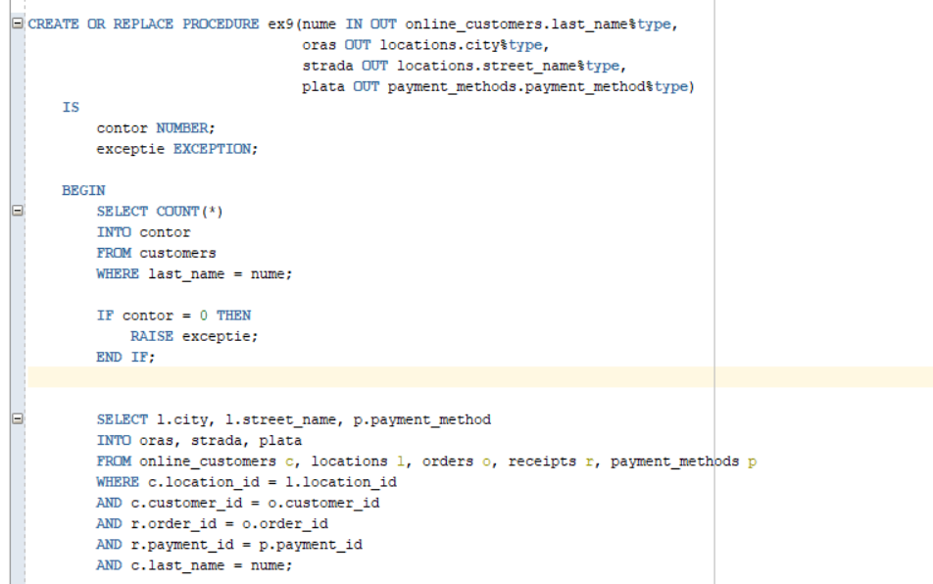

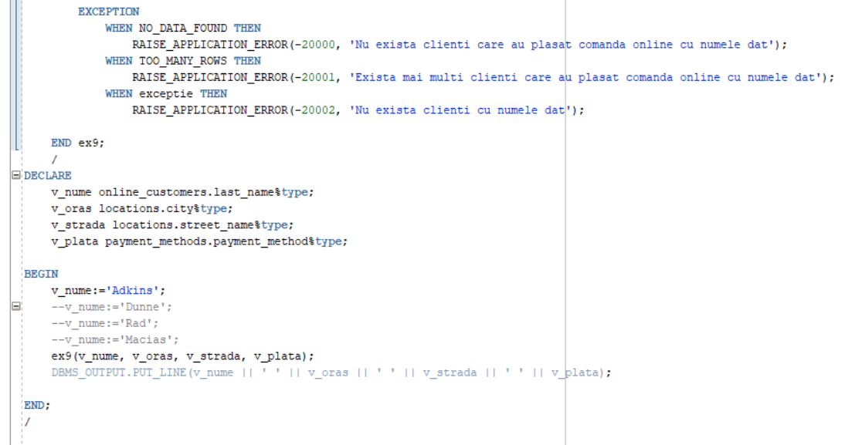

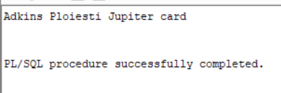

Prima exceptie:

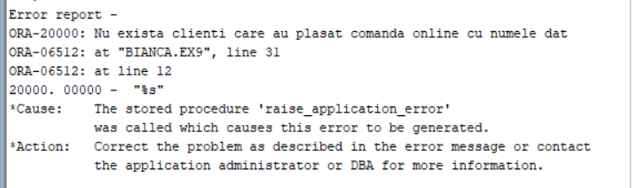

A doua exceptie:

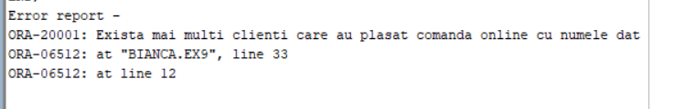

A treia exceptie:

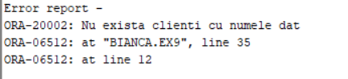

Ex10. Definiți un trigger de tip LMD la nivel de comandă. Declanșați trigger-ul.

Trigger care interzice stergerea datelor din tabelul JOBS.

CREATE OR REPLACE TRIGGER ex10

BEFORE DELETE ON jobs

BEGIN

RAISE_APPLICATION_ERROR(-20001, 'Este interzisa stergerea datelor din tabelul JOBS');

END;

/

DELETE FROM jobs

WHERE job_id = 'ASC';

select * from jobs;

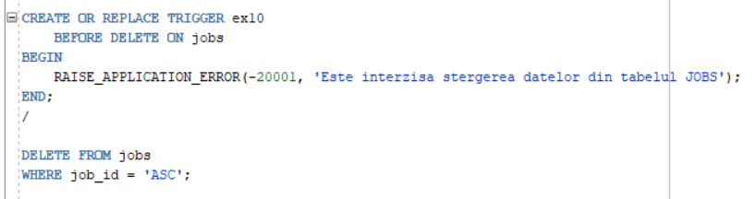

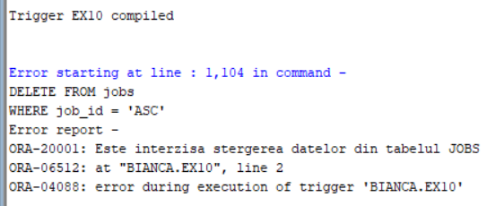

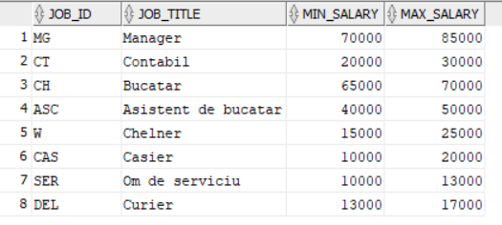

Ex11. Definiți un trigger de tip LMD la nivel de linie. Declanșați trigger-ul.

Trigger care interzice cresterea salariului unui angajat cu mai mult de 10%.

CREATE OR REPLACE TRIGGER ex11

BEFORE UPDATE ON employees

FOR EACH ROW

BEGIN

IF (:NEW.salary - :OLD.salary > :OLD.salary*(10/100)) THEN

RAISE_APPLICATION_ERROR(-20001, 'Salariul nu poate creste cu mai mult de 10%');

END IF;

END;

/

UPDATE employees

SET salary = salary + 2000

WHERE employee_id = 107;

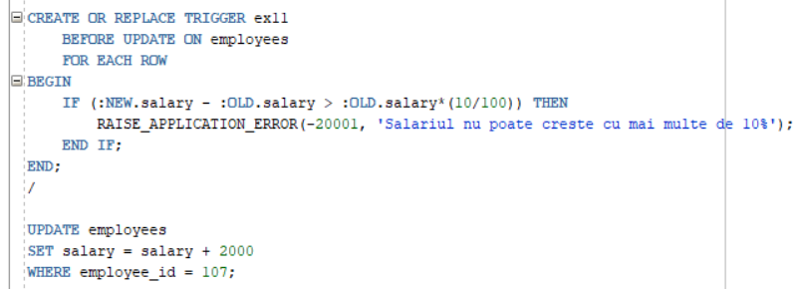

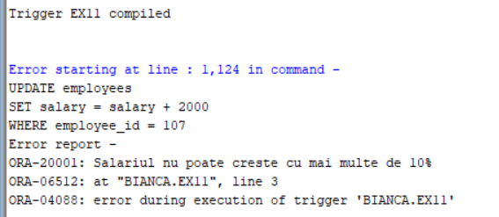

Ex12. Definiți un trigger de tip LDD. Declanșați trigger-ul.

Trigger care se declanseaza la fiecare executie de operatii LDD si salveaza modificarile in tabela userB.

CREATE TABLE userB(nume_bd VARCHAR2(50),

user_logat VARCHAR2(30),

eveniment VARCHAR2(20),

tip_obiect_referit VARCHAR2(30),

nume_obiect_referit VARCHAR2(30),

data TIMESTAMP(3));

CREATE OR REPLACE TRIGGER ex12

AFTER CREATE OR DROP OR ALTER ON SCHEMA

BEGIN

INSERT INTO userB

VALUES(SYS.DATABASE_NAME, SYS.LOGIN_USER,

SYS.SYSEVENT, SYS.DICTIONARY_OBJ_TYPE,

SYS.DICTIONARY_OBJ_NAME, SYSTIMESTAMP(3));

END;

/

ALTER TABLE locations

ADD country VARCHAR(40);

select * from locations;

select * from userB;

ALTER TABLE locations

DROP COLUMN country;

